Name :SK.Kashifa

Registration no :192121135

Jewellery loan

Class diagram :

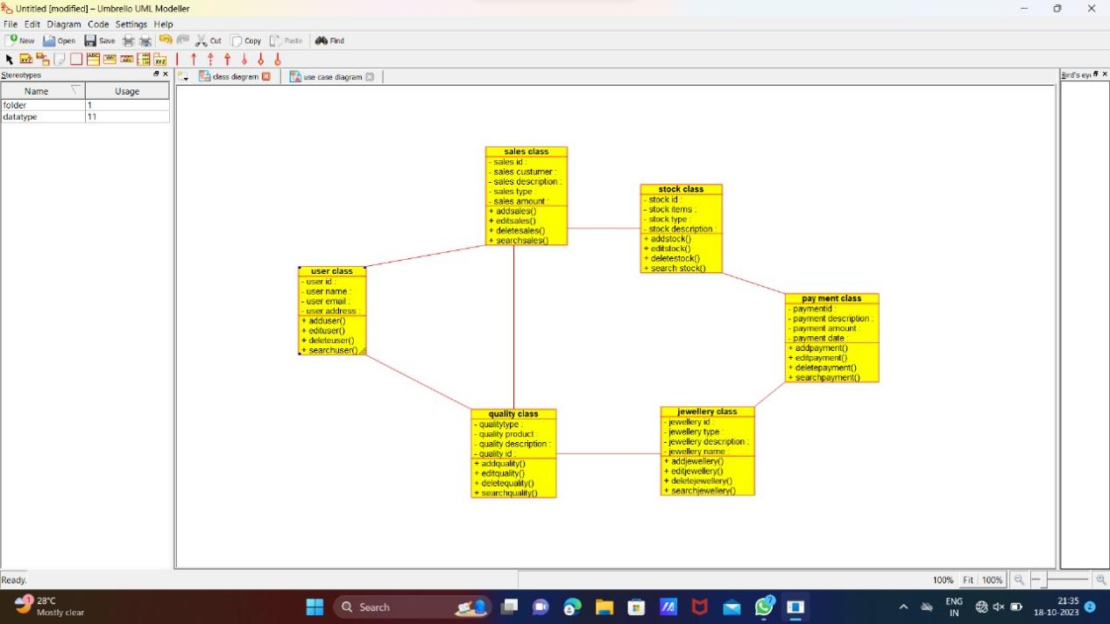

Usecase diagram :

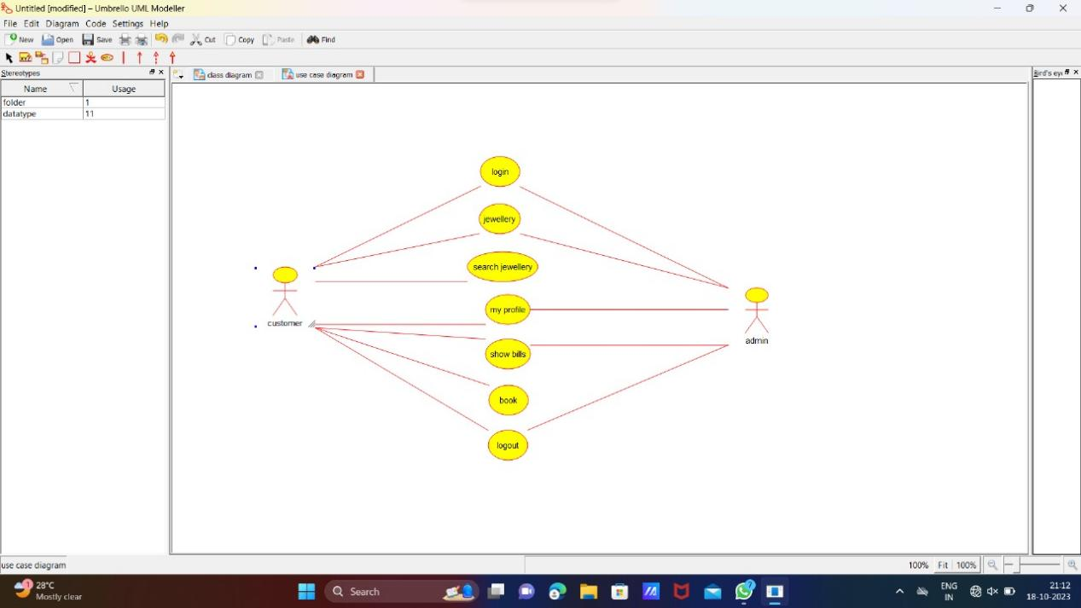

Activity diagram :

